Lab 3: Computer Networks: Vedanth Mapakshi

1. Remote desktop connection: Host to Guest (Virtualbox windows server):

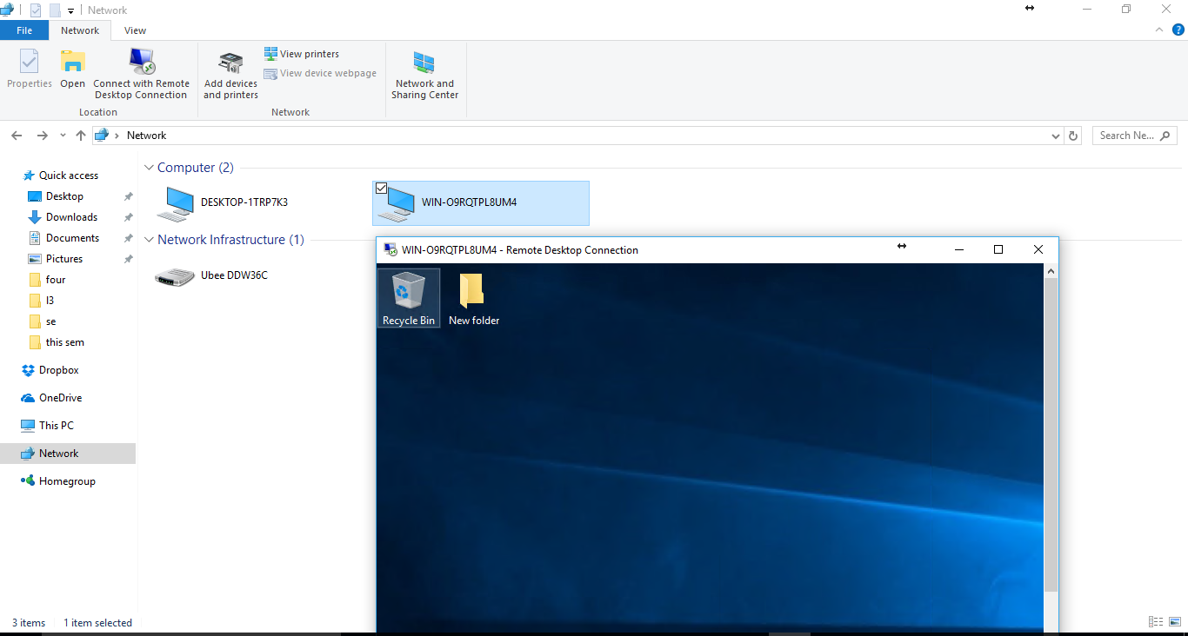

1. RDP Teamviewer from UTRGV CS Lab using teamviewer web client to personal pc

